FOOD MANAGEMENT SYSTEM

Use-Case Specification: Sign up

Version <1.0>

Revision History

|  |  |  |  |
| --- | --- | --- | --- |
| **Date** | **Version** | **Description** | **Author** |
| <7/12/2020> | <1.0> | <details> | <Nguyen Thu Trang> |

Table of Contents

1. Use-Case Name 4

1.1 Brief Description 4

2. Flow of Events 4

2.1 Basic flow 4

2.2 Alternative flow 4

2.2.1 <First Alternative flow> 4

2.2.1 <Second Alternative flow> 4

3. Special Requirement 4

3.1 <First Special Requirement> 4

4. Preconditions 4

4.1 <Precondition One> 4

5. Posstcondition 4

5.1 <Postcondition One> 4

6. Extension Points 5

6.1 < Name of Extension Points> 5

**Use-Case Specification: Sign up**

1. **Use-Case Name**
   1. **Brief Description**

This use case defines the step of signing up. The system allow customer to create account in order to use product management system

* 1. **Actor**

Customer

1. **Flow of Events**
   1. **Basic Flow**

First, customer access to the product management system, click on Sign up button. The system display sign up form. Customer fills in this form follow by system request. System checks valid of information. If valid, system display successful message

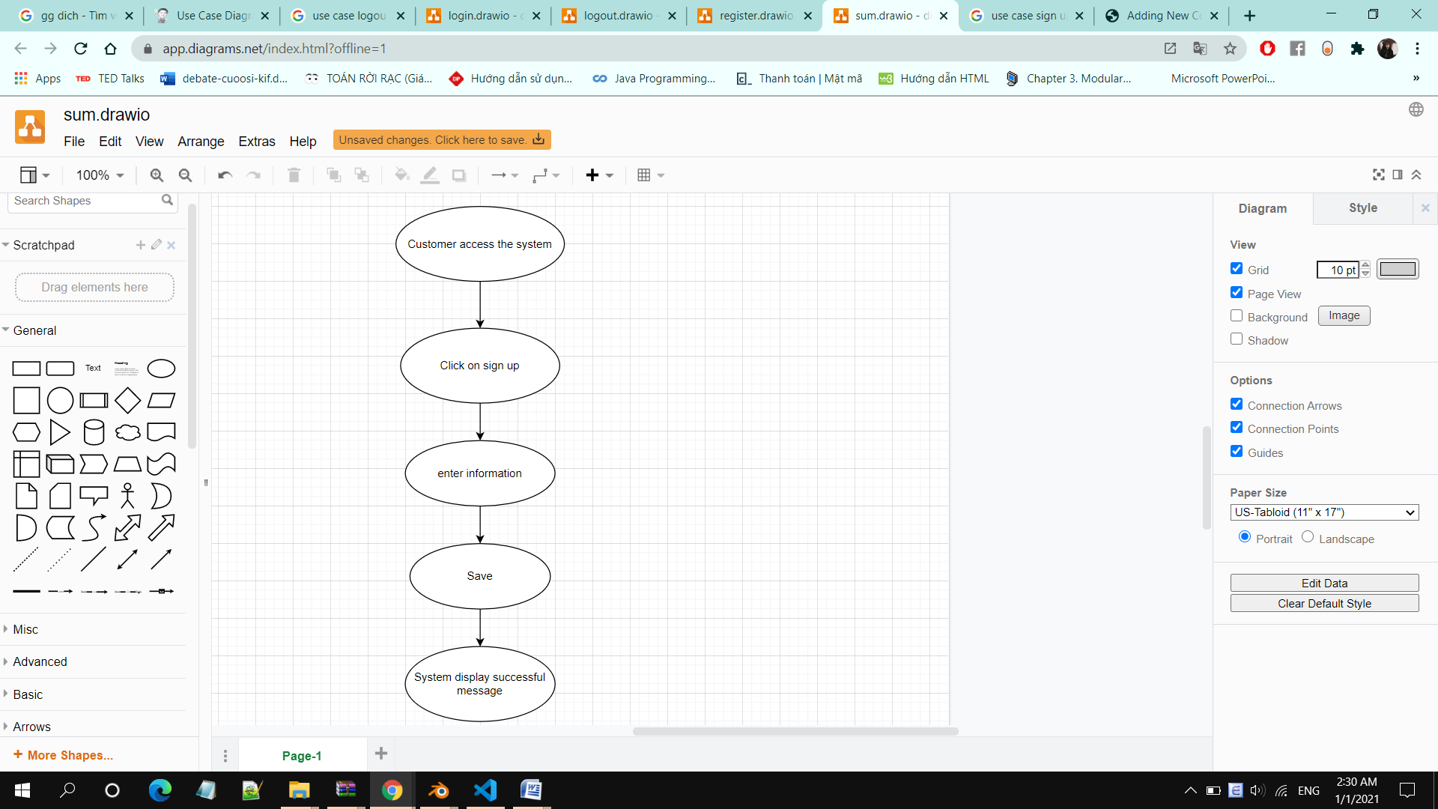

1. **Special Requirements**

Customer must know how to use the product management system.

1. **Preconditions**

Customer input information following to registration form request

1. **Postconditions**

System register successfully and redirect to Home pages

1. **Extension Points**

No extension points.